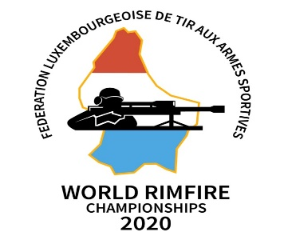
4th WRC - EUROSTAND - VOLMERANGE LES MINES
September 21st - September 26th, 2020
________________________________________________________________________________

Schedule

Sunday 20th September 2020
Unofficial Practise Day
Monday 21st September 2020
Official Practice Day 1 –Technical meeting
Tuesday 22nd September 2020
Official Practice day 2 – Delegates meeting
Wednesday 23rd September 2020
Opening Ceremony
Team Championship – Day 1
Thursday 24th September 2020
Team Championship - Day 2
Friday 25th September 2020
Individual Championship – Day 1
Saturday 26th September 2020
Individual Championship – Day 2
Awards ceremony & Banquet

